

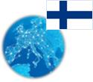 **Finland** *Energy Union factsheet[1]*

1. **Macro-economic implications of energy activities**

Energy and transport are key sectors for the overall functioning of the economy as they provide an important input and service to the other sectors of the economy. The combined activity of these two sectors[2] accounted for 7.3 % of the total value added of Finland in 2015. Similarly, their share in total employment[3] was 6.4 % in 2015, of which 5.9 % in the transport sector and 0.5 % in the energy sector.

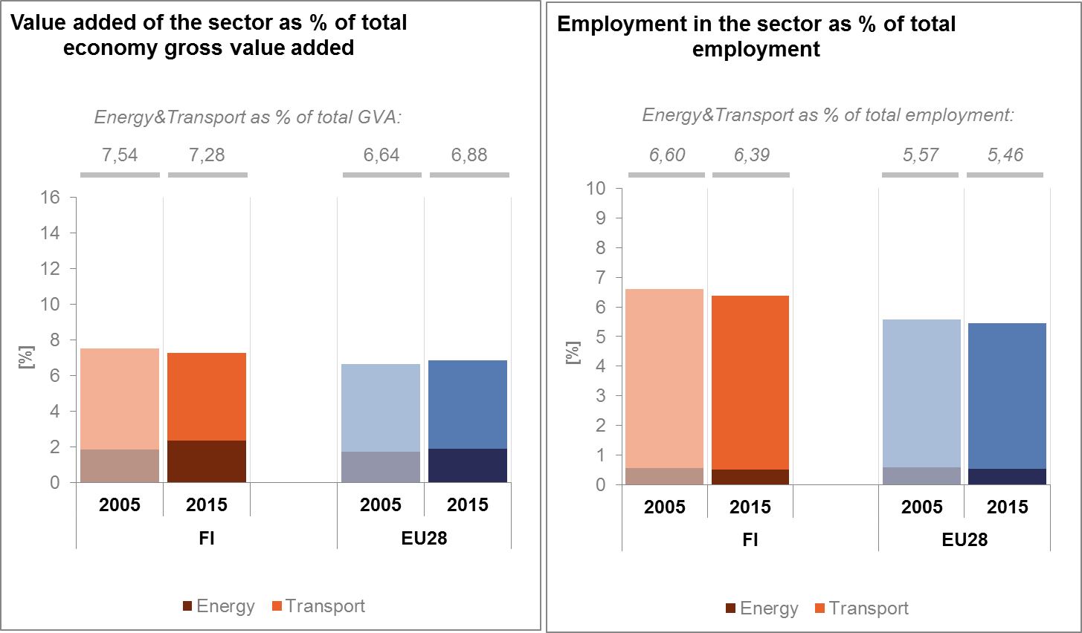

*(source: Eurostat)*

The decarbonisation of the energy and transport sectors will require significant investments and economic activity beyond the remit of these sectors themselves. The energy transition implies a structural shift in economic activity. Energy-related investment and jobs will in part migrate from traditional fossil fuel based activities towards construction, equipment manufacturing and other services related to the deployment of low carbon and clean energy technologies. At the moment, the efforts related to the low-carbon and clean energy transition in sectors beyond energy can only be partially quantified and are therefore not included in this analysis.

In the case of the renewable energy sector, both the direct as well as the indirect effects on employment can be estimated. According to EurObserv'ER, in 2015, the share of direct and indirect renewable energy related employment in total employment of the economy in Finland was at about 1.36 %, above the EU average of 0.54 %. This represents about 31000 workers. The turnover of the renewable energy industry in the same year was estimated at around EUR 3.53 billion, the largest part being attributed to the biomass (EUR 2.3 billion) followed by wind (EUR 570 million), heat pumps (EUR 350 million) and biofuels (EUR 200 million) industries.

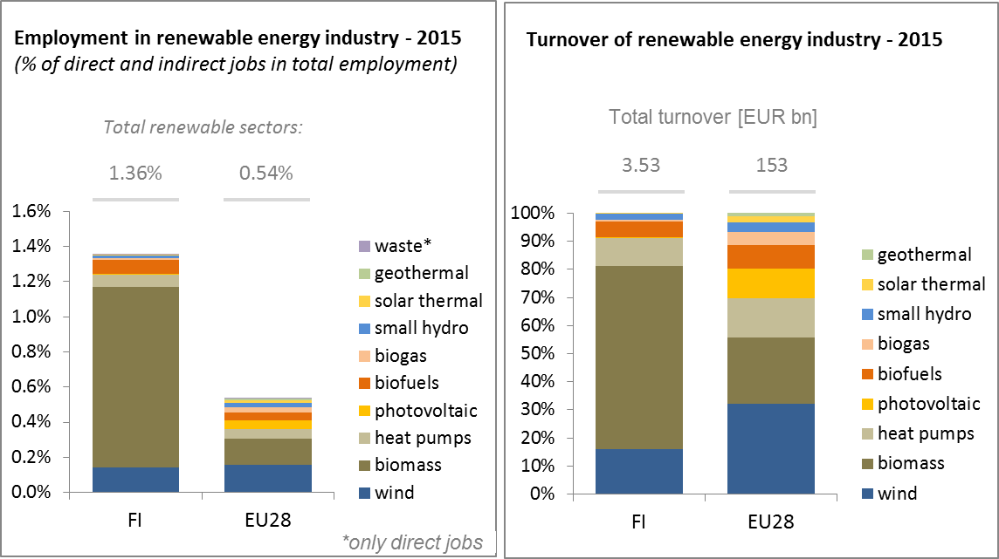

*(source: EC based on Eurobserv'Er and Eurostat)*

An indication of the level of efforts and challenges encountered by Finland in the energy sector is given by the Gross fixed capital formation (GFCF). Investments in the electricity and gas sectors, which are taken as reference sectors, have been on an increasing trend since 2010. They represented around 1% of the country's GDP in 2015, higher than in the pre-crisis period.

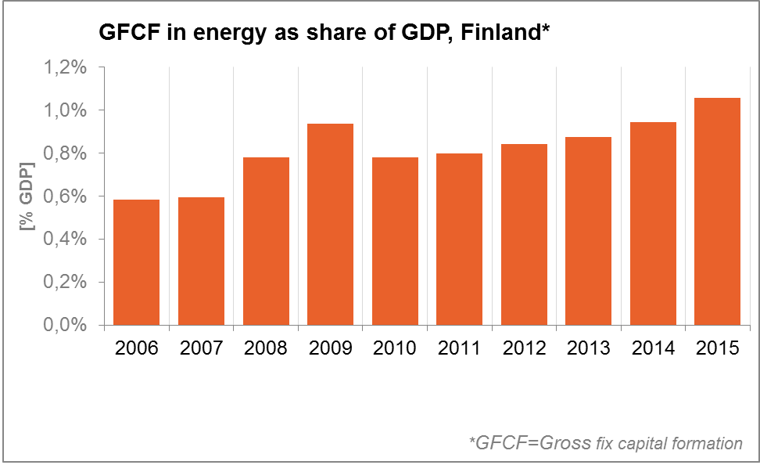

*(source: Eurostat)*

In terms of trade, Finland is a net importer of fossil fuels and electricity. The trade deficit in energy products has fallen from about 3 % of GDP in 2005 to 1.5% in 2015, influenced by improvements in energy efficiency and an increase of domestic renewable energy sources and by the decrease in the prices of energy commodities. The largest decrease is accounted for by petroleum products. The trade deficit for gas has also significantly reduced from 0.5 % of GDP in 2005 to less than at 0.05 % of GDP.

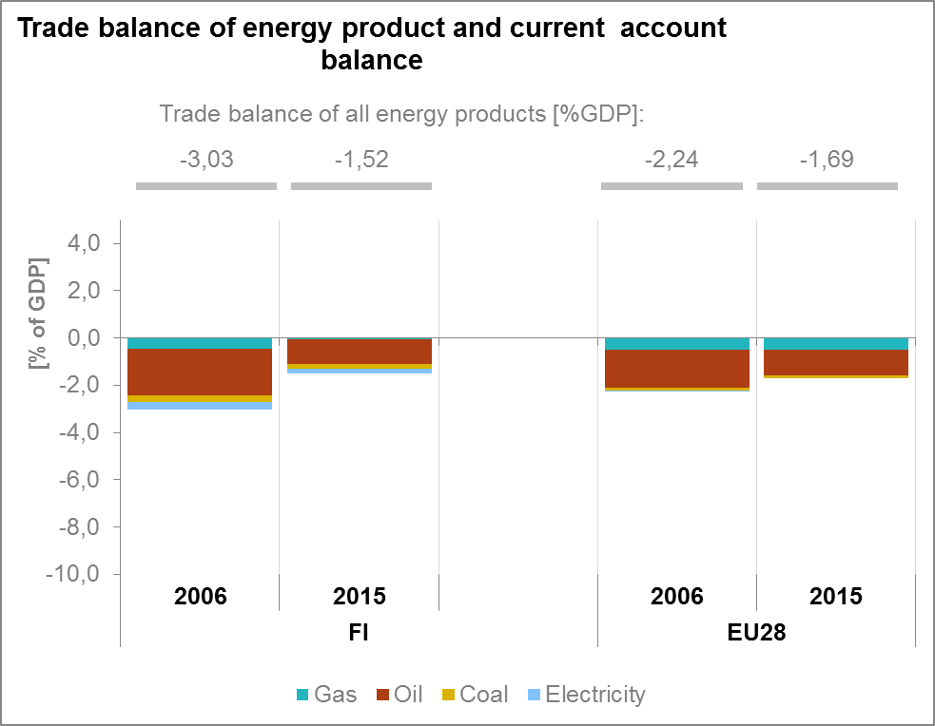

*(source: Eurostat)*

1. **Energy security, solidarity and trust**
   1. **Energy Mix**

In comparison to the average energy mix in the EU, Finland's gross inland energy consumption has a much higher share of renewable energy (33 % vs 13 %) and a higher share of nuclear energy (18.9% vs 13.6 %). Conversely, natural gas has a much lower importance in Finland (7.1 % vs 22 %). To a lesser extent, this applies as well for oil (27.6 % vs 34.4 %) and solid fuels (12.7 % vs 16.2 %).

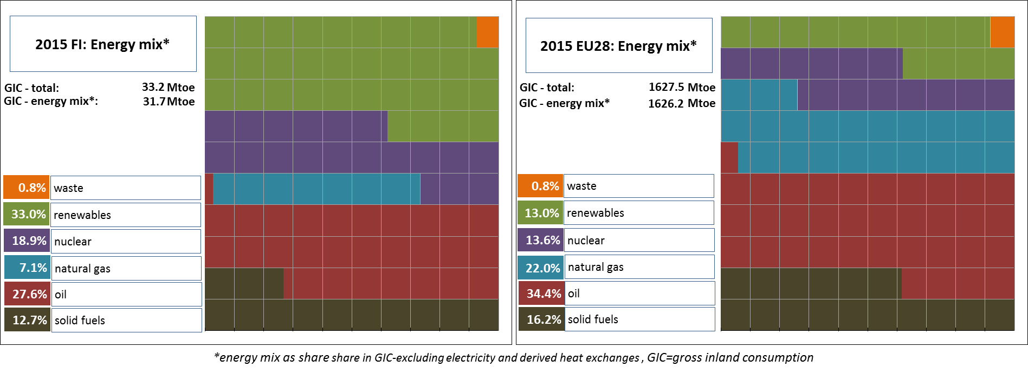

* 1. **Import dependency and security of supply**

46.8 % of Finland's energy consumption is covered by import, less than the EU average. This is due to the high importance of domestic renewables and nuclear energy in the energy mix[4], which together meet almost half of the country's energy needs.

The overall import dependency of Finland recorded a decrease of about 7.3 percentage points (p.p.) between 2005 and 2015, whilst at the EU level, import dependency increased by 1.9 p.p. over the same period. However, Finland imported almost all its natural gas, oil and hard coal in 2015. Russia was the sole supplier of natural gas to Finland, being also the dominant supplier of crude oil (83 %) and hard coal (approximately 63 %). The associated risk is only partly alleviated by the below EU average share of natural gas in the country's energy mix.

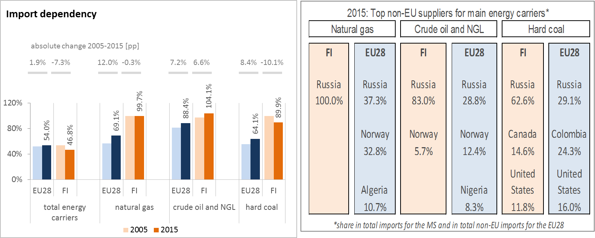

*(Source: Eurostat)*

Nuclear power is considered domestic in the Eurostat statistics although the nuclear fuel is imported. In Finland, in 2015, 35 % of the imported nuclear fuel came from Russia, 32 % from Germany and 32 % from Sweden. 27 % of the electricity supply was produced by nuclear power.

The security of gas supply Regulation requires that, if the single largest gas infrastructure fails in one Member State, the capacity of the remaining infrastructure is able to satisfy total gas demand during a day of exceptionally high gas demand. Finland complies with this rule using demand-side measures, such as an obligatory fuel-switching mechanism for its heating plants, in case of gas supply disruption.

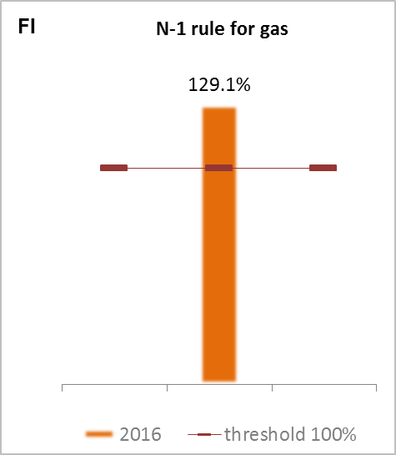

*(source: gas coordination group)*

1. **Internal market**
   1. **Interconnections and wholesale market functioning**
      1. **Electricity**

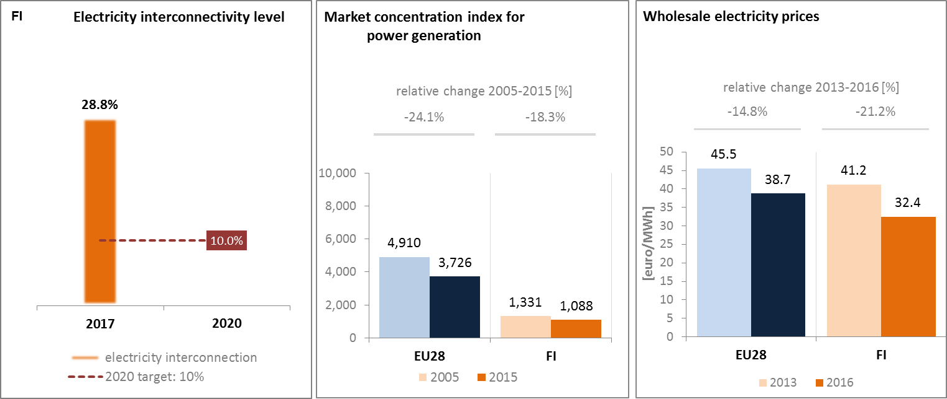

*(source: EC services based on ENTSOE source: EC services based on ESTAT source: EC services based on Platts and European power exchanges)*

Finland is part of the Nordic and Baltic wholesale electricity market. The Finnish electricity system is directly connected to the Swedish, Norwegian and Estonian systems and indirectly through these to the other Nordic countries and the other Baltic States, and continental Europe. In 2017, the electricity interconnection level[5] of Finland was almost 29 %, well above the 2020 target of 10 %.

The good electricity connectivity to the Nordic electricity market and Western Europe and the liberalised energy market led to a very dynamic power generation market with low and decreasing wholesale electricity prices. Concentration of the power generation market is much below EU average. Wholesale electricity prices are well below the EU average and between 2013 and 2016 recorded a higher decrease than the EU average (21 % in Finland vs 15 % in the EU).

However, wholesale electricity prices in Finland are not fully aligned with those of its Nordic neighbours. The main reason for this is the insufficient capacity in the transmission interconnections from the Nordic and Baltic market area. It is also affected by the use of imported electricity from Russia, even though this has decreased after 2011 when Russia introduced capacity payments on the export of electricity. Russian imports are more and more replaced with imports from Nordic markets. In that context, Finland's electricity transmission connections with Sweden are not sufficient for importing large volumes of electricity during peak demand periods. For this reason, an improvement of the Fenno-Skan 1 interconnection with Sweden and the construction of a third Finland-Sweden North interconnection are envisaged. Conversely, price convergence with Estonia has improved following the completion of the EstLink2 project, financed via the European Energy Programme for Recovery.

Finland will most likely remain an electricity importer until the completion of the new nuclear power plant project Olkiluoto-3, which is experiencing significant delays. In addition, Finland plans to extend the operation of existing reactors, and to build new nuclear capacity, if relevant, in the future. In this context, continued efforts for a comprehensive management infrastructure from waste/spent fuel generation to disposal will be needed.

* + 1. **Gas**

Wholesale gas prices are higher than the average EU gas prices. In addition, gas market competition is currently lacking.

The market is tightly regulated as there is no liberalised wholesale market and end users have no choice of supplier. The situation is meant to improve thanks to the building of a new interconnector with Estonia. The Connecting Europe Facility's financing agreement on the Balticconnector pipeline project has ensured agreement for the construction of this gas pipeline linking Finland and Estonia, a project included in the list of Projects of Common Interest. The project, which is to be commissioned by 2020/2021, has obtained a significant financial support under the EU's Connecting Europe Facility programme, including a grant for works of €187.5 million (in August 2016). Once completed, conditions would be granted for a gas market opening to competition.

In addition, Finland has continued the development of five smaller scale LNG terminals (each between 10-50 tcm of LNG storage) of which at least one located in Hamina Kotka is to be connected to the high pressure transmission network. The terminal located in Pori (30 tcm of LNG storage) was commissioned in August 2016 and it is the first of the smaller scale terminals to be completed. The remaining four will be commissioned in 2017 and 2018.

On that basis, a new Natural Gas Market Act was passed in the Parliament in June 2017. According to the Act, the wholesale and retail markets for natural gas will be opened for competition in the beginning of 2020.

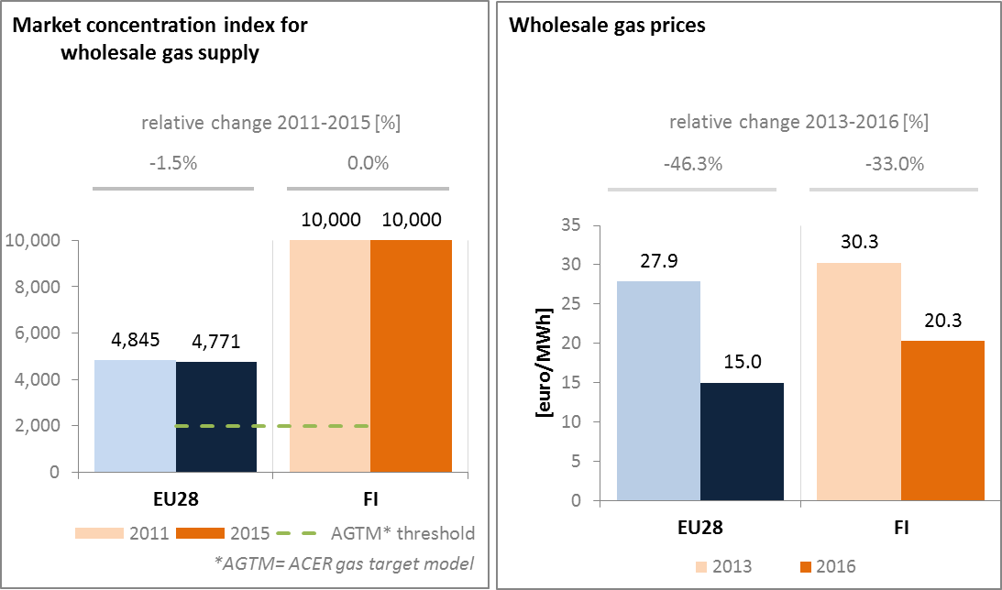

*(source: ACER for the left graph and European Commission services based on on Platts, gas hubs, Eurostat for the right graph)*

* 1. **Retail electricity and gas markets**
     1. **Electricity**

In 2015, households' electricity prices in Finland were below the EU average. Between 2013 and 2015, average band retail electricity prices for households decreased, but to a lesser extent than the wholesale prices. This can be partially explained by an increase in taxes and levies. Since 2010, the excise duty rate increased by about 50%. Overall, taxes and levies now represent 34 % of households' electricity prices.

Finland has also experienced a full roll-out of smart meters, and high annual switching rates by consumers from one electricity supplier to another. In fact, in 2015, around 98 % of final customers had installed an electricity smart meter and 12.5 % of consumers changed suppliers, twice as much as the EU average. Data handling and protection should be further facilitated by a data hub, covering Denmark, Finland, Sweden and Norway. The objectives of the data hub are to stimulate competition and innovation, increase transparency through data access and protection and to create efficient retail markets, where increasing amounts of data from smart meters can be sufficiently utilised.

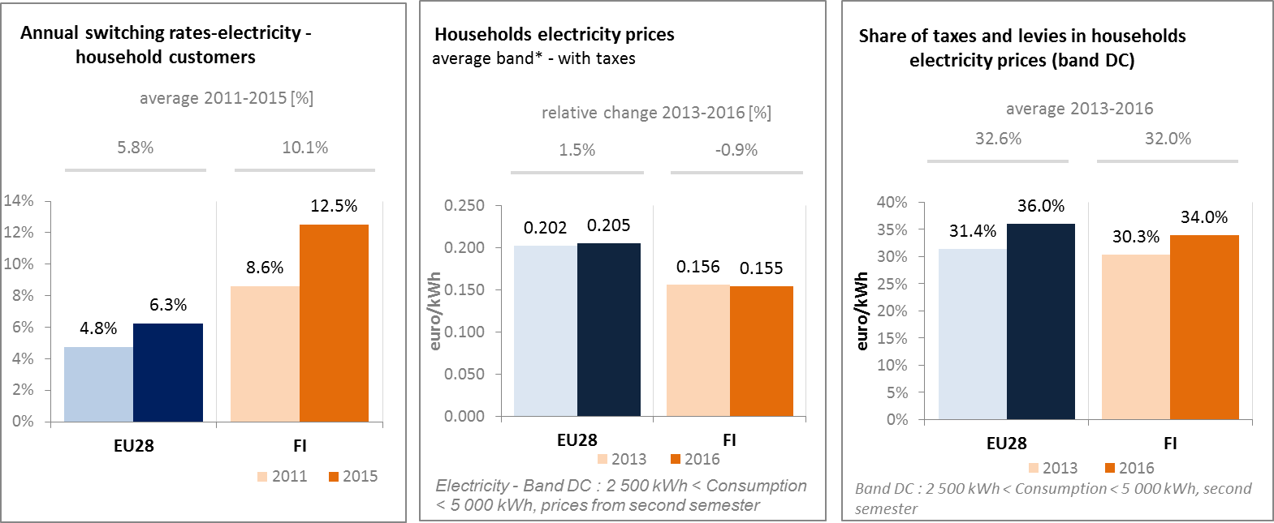

*(source: ACER) (source: Eurostat) (source: Eurostat)*

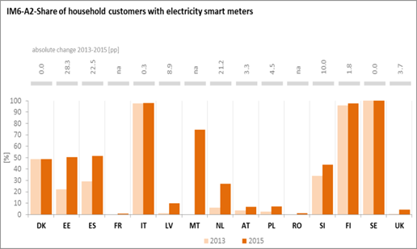

*(source: ACER)*

* + 1. **Gas**

Gas represents a negligible share of households' energy consumption. Therefore, Finland has no significant retail market for households. (Retail markets for industry are discussed in the section on competitiveness).

* + 1. **Market performance indicators**

According to the periodical survey of the European Commission, Finnish consumers are more satisfied than the EU average about the services received on energy retail markets.

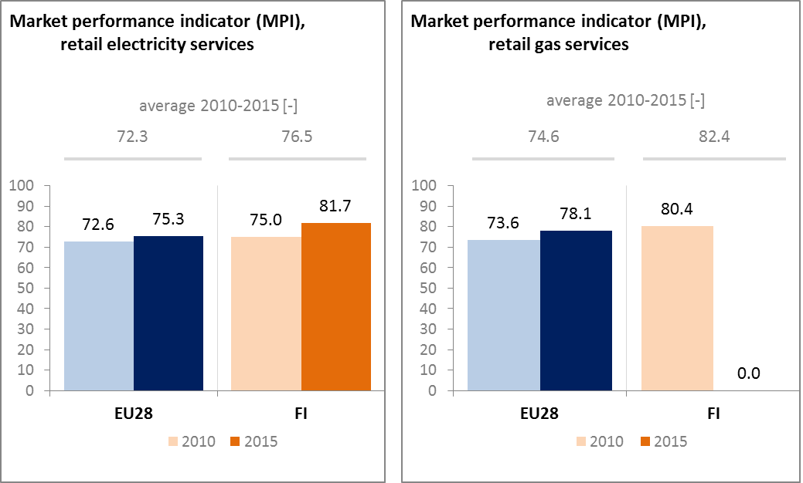

*(source: DG JUST survey)*

* 1. **Energy affordability**

In Finland, although climate conditions imply significant heating needs in EU comparison, the share of energy in total household expenditures of the lowest quintile of population is among the lowest in the EU. Furthermore, only a very limited part (less than 4 %) of citizens below the at-risk-of poverty threshold considers that they are unable to keep their home adequately warm. This can be explained by purchasing power and consumption expenditures of households, high energy efficiency standards of residential buildings, and low retail electricity prices. The concept of vulnerable consumers has been defined. If a consumer is in a vulnerable situation and, according to Finnish legislation, principally through no fault of their own, it can benefit from additional protection in case of non-payment of energy bills.

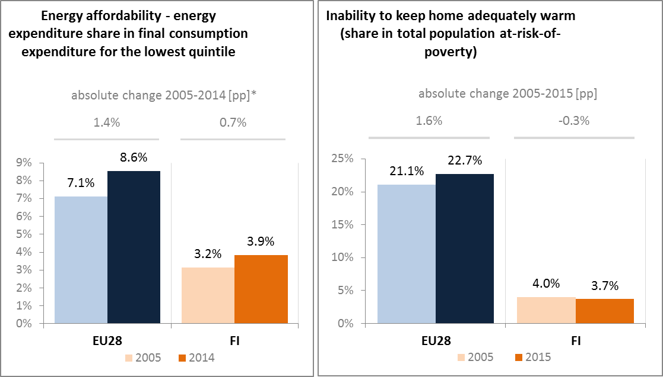

*(source: ad-hoc data collection of DG ENER based on HBS with the support of Eurostat and national statistics)*

1. **Energy efficiency and moderation of demand**

Finland decreased its primary energy consumption by 4 % to 31.95 Mtoe between 2005 and 2015. Over the same period, final energy consumption also decreased by 4 % to 24.18 Mtoe. However, these percentage reductions rates are significantly below the EU average. Therefore, Finland has already achieved levels of primary and final energy consumption below the indicative national 2020 targets (35.9 Mtoe in primary energy consumption and 26.7 Mtoe in final energy consumption). However, efforts would need to continue to keep up with the EU level of ambition and to ensure the targets can be met, in a context where economic activity (i.e. bio refineries, forest industry, etc.) is growing.

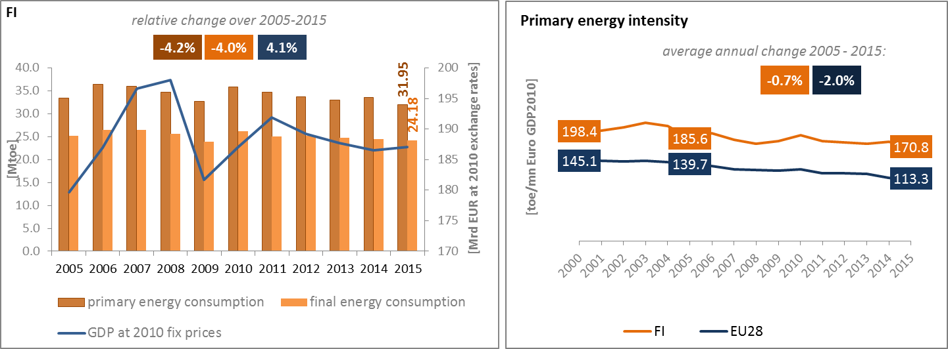

*(source: Eurostat)*

In 2015 in Finland, industry was the largest energy consuming sector, representing a 44 % share of the total final energy consumption, which is well above the EU average (25%). The pulp and paper industry on its own represents more than half of Finland's energy consumption in industry. Conversely, the energy consumption of Finland's transport sector was at around 20 % well below EU average. The energy consumption of the residential and services sectors in Finland are slightly below the EU average, with a share in total final energy consumption of 20 % and 11 % respectively. Since 2005, similar trends in Finland and at EU level have been observed in the evolution of the share of final energy consumption across sectors: the industry share is decreasing, while the one on transport is increasing.

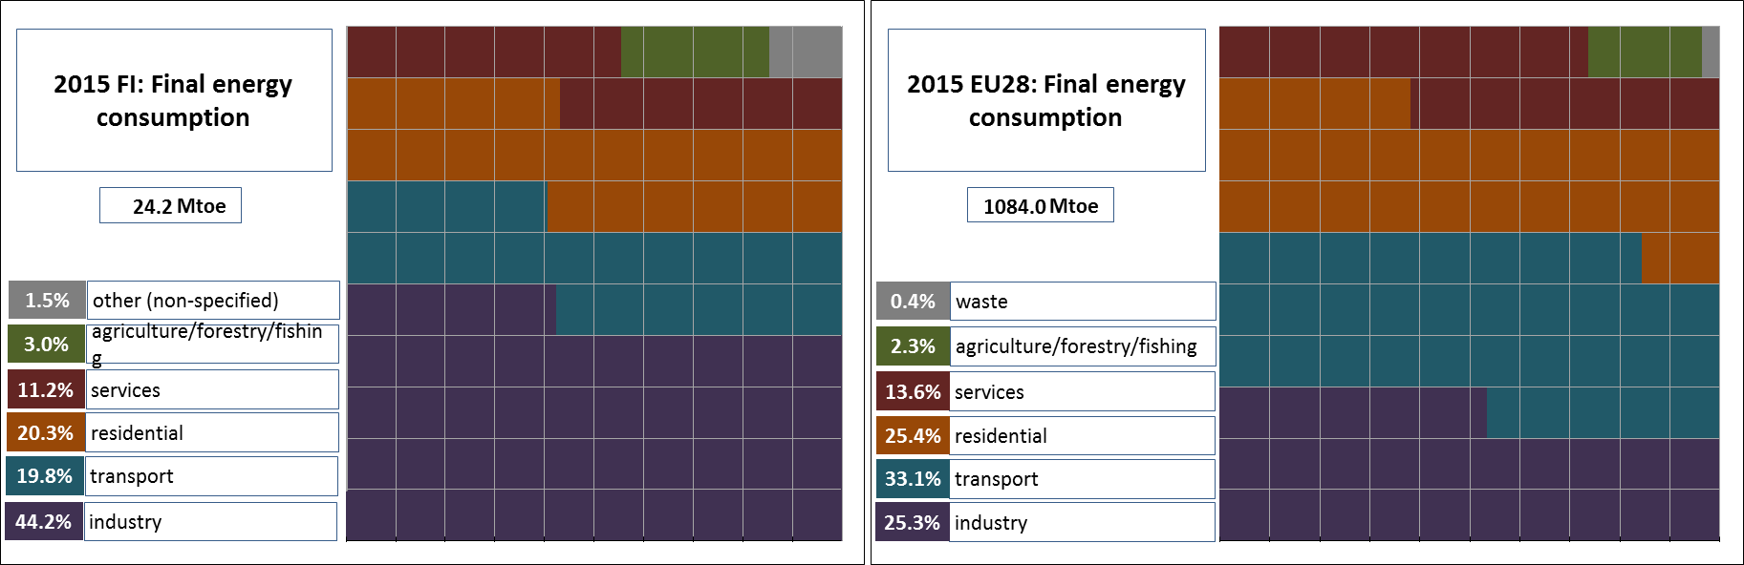

*(source: Eurostat)*

Although primary energy intensity decreased over the 2005-2015 period, it remains above EU average and it decreased at a slower pace. A sectoral assessment shows that the energy intensity of Finland's industry is one of the highest in the EU, and has been quite stable over the last ten years. This is also, to a lesser extent, true in the services sector, and the energy intensity of households is also above the EU average.

Additional efforts could therefore be envisaged to improve energy intensity in these various demand sectors, but keeping in mind that certain industrial processes (i.e. steel) are already very efficient and so the potential for additional improvements remains limited. A positive development concerns the use of European Funds for Strategic Investments (EFSI) funds to finance various nearly zero-energy building projects. The use of EU Cohesion policy funds in energy efficiency demonstrations in public infrastructure and in SMEs in Finland, in line with its operational programme, is also expected to bring benefits. Energy efficiency agreements (voluntary agreements) are used to promote energy savings in a broad range of industrial sectors and local communities. New agreements for the period 2017-2025 have just been signed and are expected, according to government's estimates, to contribute for about half of Finland's energy savings obligations linked to the implementation of the EU Energy Efficiency Directive.

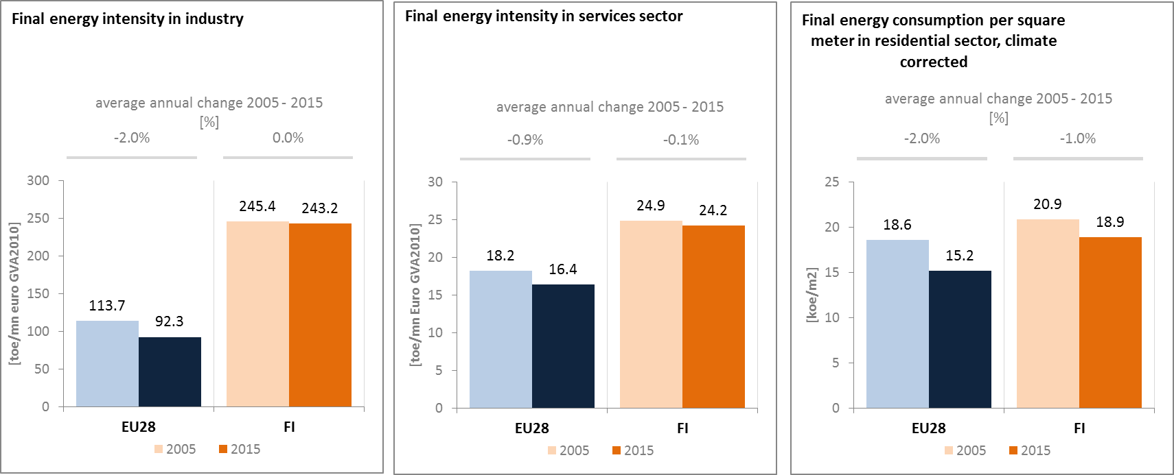

*(source: Eurostat) (source: Eurostat) (source: Odyssee database)*

Between 2005 and 2015, the final energy consumption in transport recorded an average annual increase of 0.3 %, slower than the 0.5 % average annual increase of the GDP. Although the decrease of freight transport activity, affected by the economic context, negatively impacted final energy consumption, this was offset by the increase of passengers transport activity which was continuously growing over the period.

The share of collective passengers land transport into total passengers' transport decreased slightly between 2005 and 2015 indicating a slightly higher use of private transport means both in Finland and at the EU level.

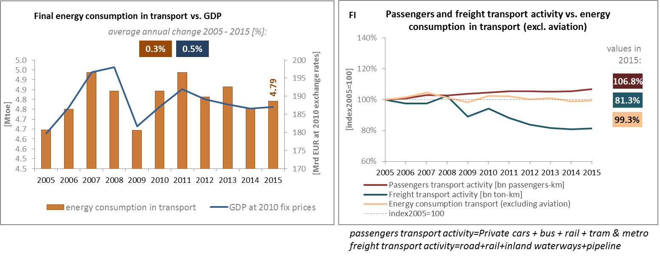

*(source: Eurostat) (source: Eurostat and DG MOVE pocketbook)*

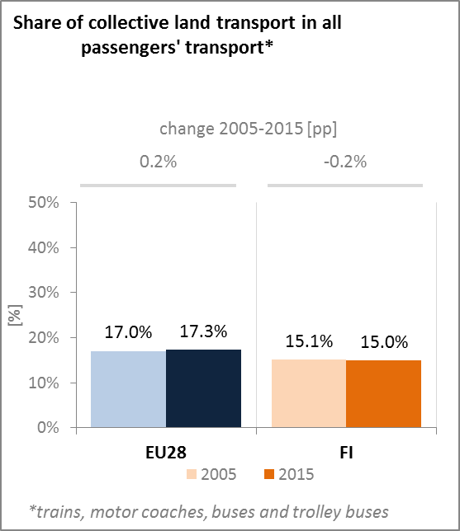

*(source: Eurostat)*

In 2016, the Finnish Government submitted a legislative proposal to Parliament, bringing the existing transport market regulations together in a unified act, the Transport Code (Liikennepalvelulaki). The Transport Code aims at creating the framework for organising publicly subsidised passenger transportations more efficiently, enhancing the implementation of new technology, digitalisation and new business concepts, and making uniform and mobile travel chains possible.

There are no road tolls in Finland. Different customer charging models are considered, such as 'time based user licence' which allows to use the infra for a specific length of time or 'pay per used kilometre' (e.g. based on mobile phone location data).

1. **Decarbonisation of economy**
   1. **GHG emissions**

In 2016, GHG emissions were 16 % below their 1990 levels, significantly below the EU average reduction of -23 %. Finland's non-ETS emissions are already 3 percentage points higher than the allocation for that year. According to the national projections, the reduction in Finland's non-ETS target for 2020 is projected to be missed with a margin of 1 percentage points.

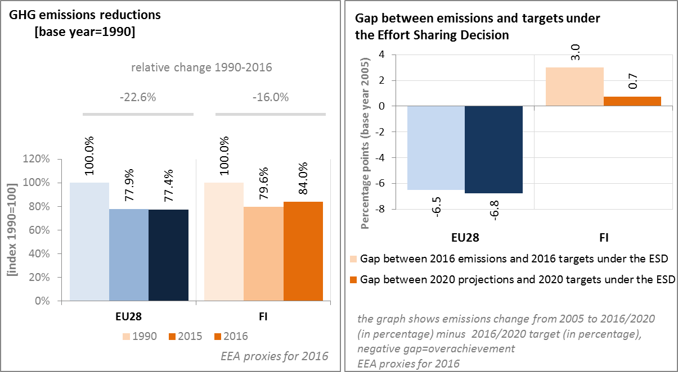

*(source: EC and EEA)*

In 2016, the GHG intensity of Finland's economy was practically the same as the EU average, decreasing at a slightly slower pace than the EU as such since 1990. In 2016, the GHG emissions per capita were 28 % above the EU average.

In 2015 in Finland, the largest sectors in terms of GHG emissions were the energy sector (about 30 % of the total GHG emissions) followed by industry (26 %), transport (20 %) and agriculture & fishery (14 %). The GHG emissions from the residential and commercial sectors were well below the EU average (i.e. 4.4 % vs 12.8 %) due to the limited direct use of fossil fuels for heating purposes.

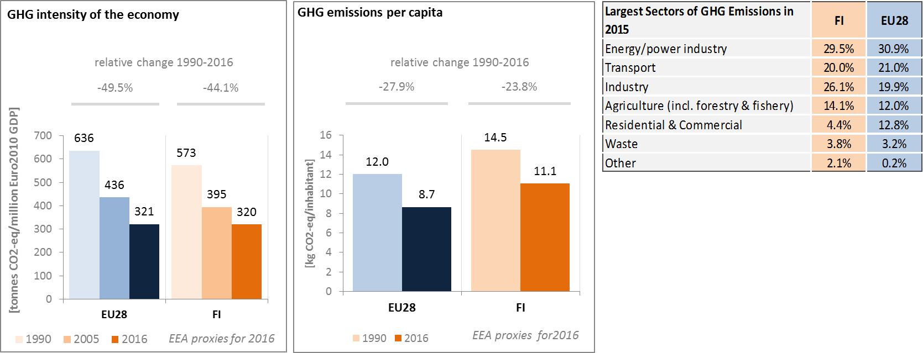

*(source: EC and EEA)*

Preliminary accounts under the Kyoto Protocol for Finland show overall emissions of +0.7 Mt CO2-eq. as an annual average in the period 2013-2015. For comparison, the annual average of the EU-28 accounted for removals of -119.0 Mt. CO2-eq. It should be noted that in this preliminary simulated accounting exercise, removals from Forest Management were capped to -2.5 Mt CO2-eq per year, due to significantly exceeding the limit of the difference between the reported sink and the accounting forest management reference level. Finland is one of four EU Member States which show overall emissions in this preliminary accounting exercise.

Emissions by Deforestation are the most important activity, by far higher than removals by Afforestation and still relatively higher than removals by Forest Management. Overall, there is a decreasing trend in emissions due to declining emissions by Deforestation over the course of the three-year period. Commission Implementing Decision 2014/224/EU of 16 April 2014, allocating Finland up to 10Mt CO2-eq. allowances to be used to compensate deforestation emissions beyond the cap applied to Forest Management, has not been included in this simulation.

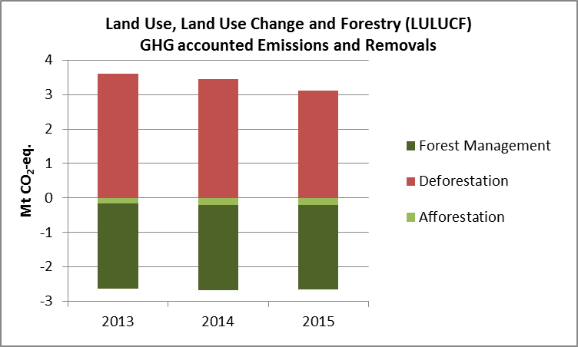

*Note: Forest Management credits are capped and presented as yearly averages when the total Forest Management credits of the considered period exceed the simulated cap over the same period.*

*(source: EC and EEA)*

**CO2 emissions in transport and alternative fuelled vehicles**

In Finland, the CO2 emissions from road transport were in 2015 at 95.6% of the 1990 levels, decreasing more prominently from 2005 onwards. This reduction of the CO2 emissions was also possible due the growing share of advanced biofuels in the transport sector. The average CO2 emissions of new cars was in 2016 above the EU average but decreased between 2005 and 2016 by about one third, more than the EU average.

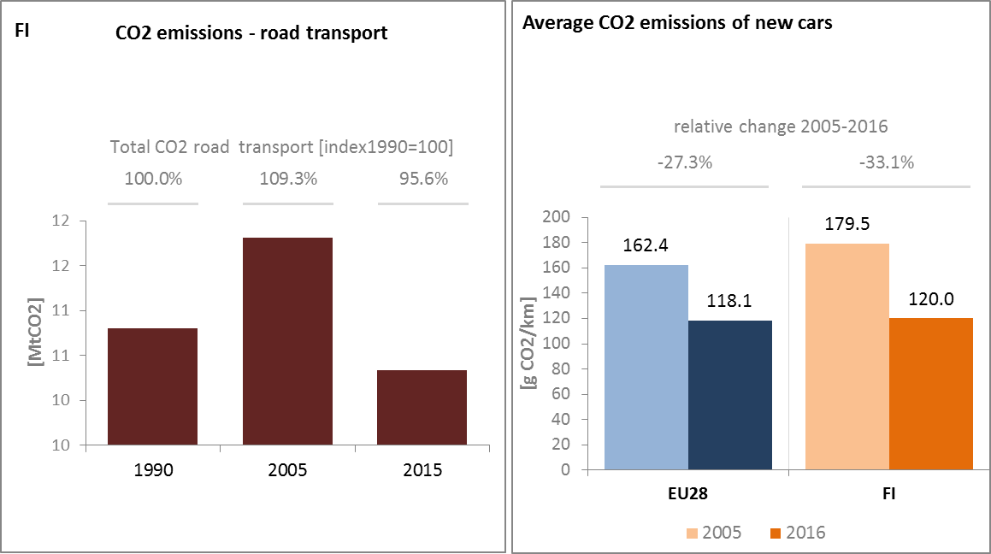

*(source: EEA/UNFCCC)*

The share of alternative fuelled cars in total sales on the Finnish market is still small (i.e. below 0.9% in 2015) but increased slowly from 2013. In 2015, 0.62 % of new cars in Finland have been hybrid-electric and electric cars. However, according to national statistics, such numbers have increased in 2016. In 2016, 1.2 % of new cars in Finland have been hybrid-electric and electric cars. Market uptake of the electric car is also supported by a growing number of charging points. The number of electric charging points in Finland has over the last four years more than tripled, from 267 units in 2013 to 911 units in 2016.

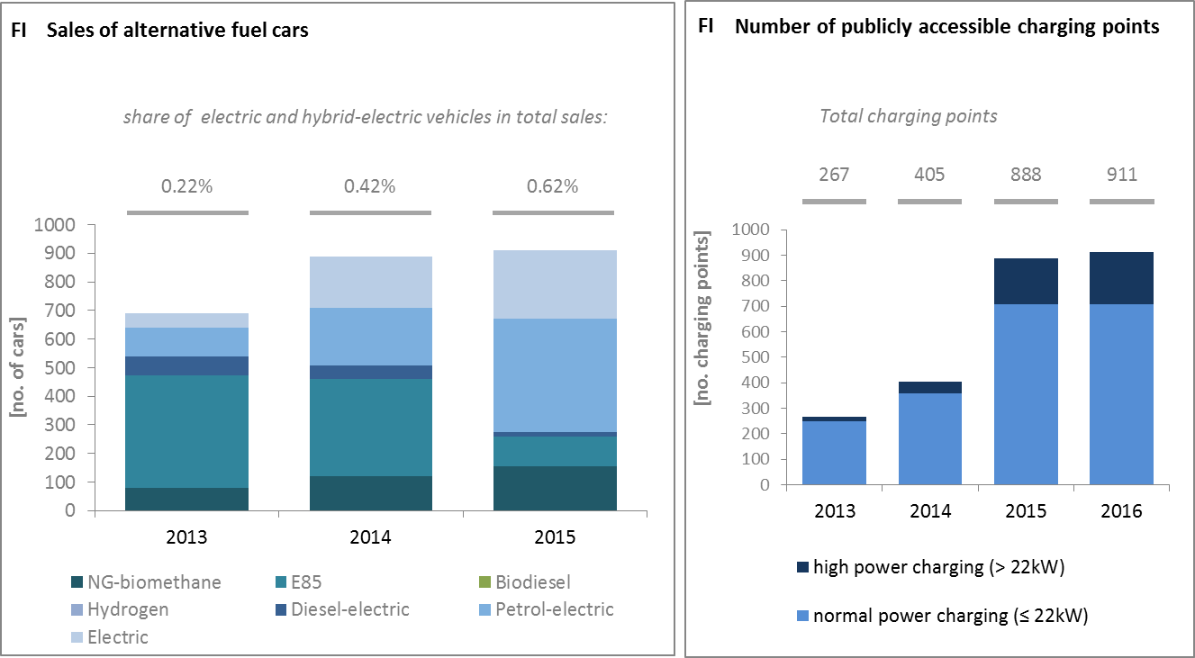

*(European Environment Agency) (European Alternative Fuels Observatory)*

Finland is contributing to lower CO2 emissions from transport also by having developed a liquefied natural gas (LNG) import terminal in Pori, aimed for industrial use as well as sea and road transport diversification.

National Policy Frameworks under Directive 2014/94/EU on alternative fuels infrastructure have to establish targets, objective and measures for the development of the market of alternative fuels in the transport sector and the deployment of the relevant infrastructure. Finland has submitted its National Policy Framework as requested under article 3 of the Directive 2014/94/EU.

A detailed assessment of the Finnish National Policy Framework in terms of its compliance with the requirements of Directive 2014/94/EU on alternative fuels infrastructure, its contribution to achievement of long-term energy and climate objectives of the Union and coherence of its targets and objectives in terms of cross-border continuity has been published as part of the Communication on Alternative Fuels Action Plans (COM(2017)652) and  the related staff working document SWD(2017)365.

* 1. **Adaptation to climate change**

In Finland, a National Adaptation Strategy (NAS) was adopted in 2005 as an independent element of the wider National Energy and Climate Strategy. The NAS revision resulted in 2014 in the publication of a new national climate change adaptation framework known as the National Adaptation Plan for Climate Change 2022. The key principle of the adaptation plan concerns the incorporation of climate change adaptation into the regular planning, implementation and development of all sectors and actions. A national monitoring group is appointed to follow and evaluate the implementation of the adaptation plan, with representatives from the relevant ministries, research institutions, and regional and local bodies and actors.

* 1. **Taxes on energy and transport and fossil fuel subsidies**

Finland uses taxation as part of their climate policy, and has a carbon tax in place. A higher rate of €62/tCO2 is applicable on transport fuels, including petrol and diesel. A lower rate of €58/tCO2 is applicable on heating oil fuels (light and heavy), natural gas, liquid petroleum gas and coal that are not used solely in electricity production. In addition to carbon tax, Finland taxes transport fuels and heating fuels based on their energy content. The energy content tax is 0.0163 €/MJ and 0.0091 €/MJ for petrol and diesel respectively. For heating fuels the tax is 7.05 €/MWh (0,0016 €/MJ). The vehicles taxes, i.e. both the circulation and registration tax, include a CO2-component.

The overall tax burden on energy and transport (including carbon taxation) in relation to GDP is 2.8%, which is 0.5 p.p. higher than the EU average. It is particularly the tax burden on transport vehicles that is higher, while fuel taxation is broadly in line with the EU-average. Taxation of heat and electricity is slightly above the EU-average, and has also shown an increase since 2007. The tax burden on vehicles and transport fuels has in contrast remained relatively stable since 2007.

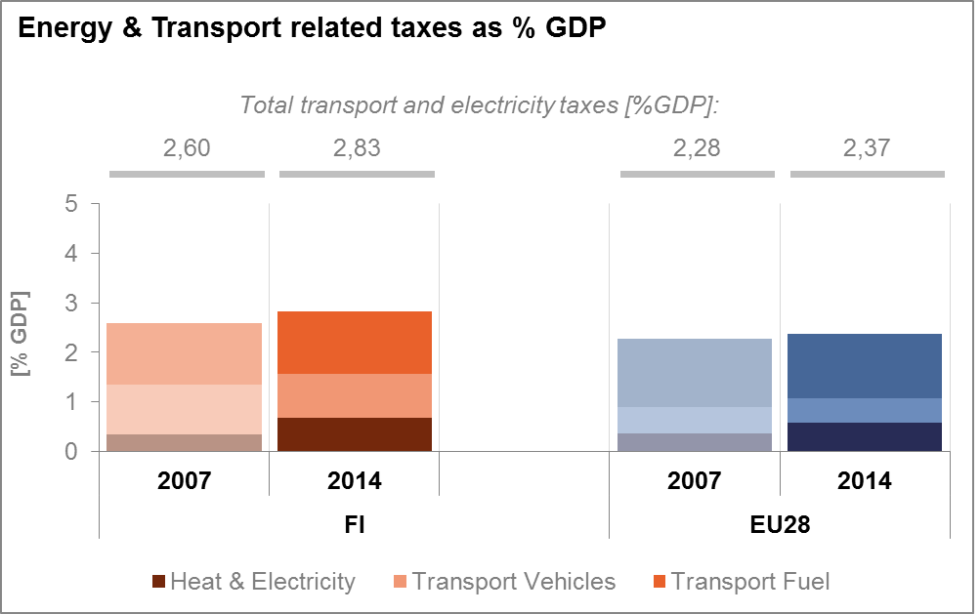

*(source: Eurostat)*

Fossil fuel subsidies have overall increased in Finland in the last decade, while they however tend to show a decreasing / stabilising trend since 2011, when its energy taxation structure was reformed with several energy tax rates increased. The energy taxation reform of 2011 included a transitional period for gas. The transitional period and tax support ended in 2015. Fuel taxation of diesel is lower than taxation of gasoline. Diesel passenger cars are subject to a higher annual vehicle tax than gasoline passenger cars to compensate the difference in fuel taxation. Subsidies to peat (which is subject to a separate energy-tax regime in Finland) are included in the coal figures in OECD statistics shown above.



*(source: OECD* *Inventory of Support Measures for Fossil Fuels 2015)*

* 1. **Renewable energy**

Finland's renewable energy share, expressed in percentage of gross final energy consumption, was 39.3 % in 2015, already above its 2020 target. Finland also met the 2013/2014 indicative trajectory for the renewables share in gross final energy consumption.

Finland is among the few EU Member States which already achieved the renewable energy share in transport, reaching 22 % in 2015. The renewable energy share is more than 50 % in the heating and cooling sector and about a third in electricity generation.

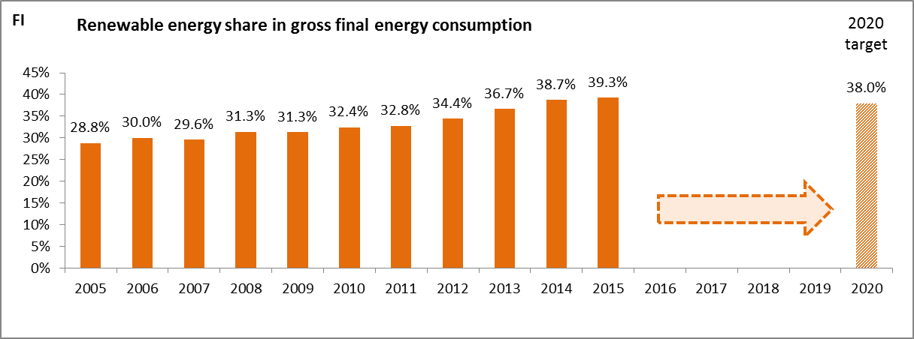

*(source: Eurostat-SHARES)*

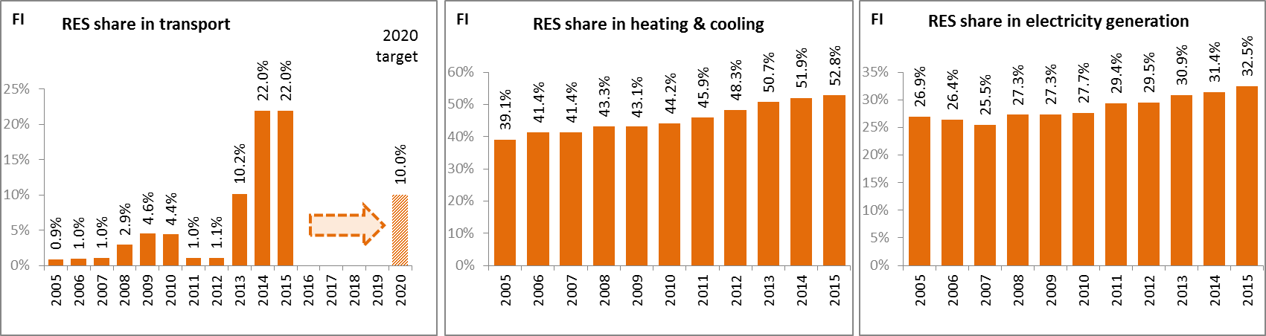

*(source: Eurostat-SHARES)*

Electricity from renewable energy sources is mainly promoted through a feed-in premium. It applies to electricity produced from wind, biomass and biogas, but is not available to small producers and PV power producers. Instead, an “energy aid”, a state grant for investments in RES production facilities, is proposed. The main support mechanism for heat produced from renewable energy sources is a “heat bonus” allocated to Combined Heat and Powerplants working on biogas and wood fuel. The cost of renewables support schemes is financed by the state budget rather than being passed onto final consumers. In transport, the main incentive for renewable energy use is a quota system. This system obliges fuel vendors to ensure that biofuels make up a defined percentage of the company’s total annual sale of fuel. Furthermore, the use of biofuels is supported through tax regulation.

Thanks to the consistent deployment of renewables since 2005, it is estimated that Finland has reduced in 2015 by about 16 % its fossil fuels consumption. In addition, it is estimated that GHG emissions are 14 % lower[6]. This is mostly due to a strong substitution of petroleum products with renewable energy (oil represents more than half of all fossil fuels substituted in Finland), and therefore linked to the use of renewable energy in transport.

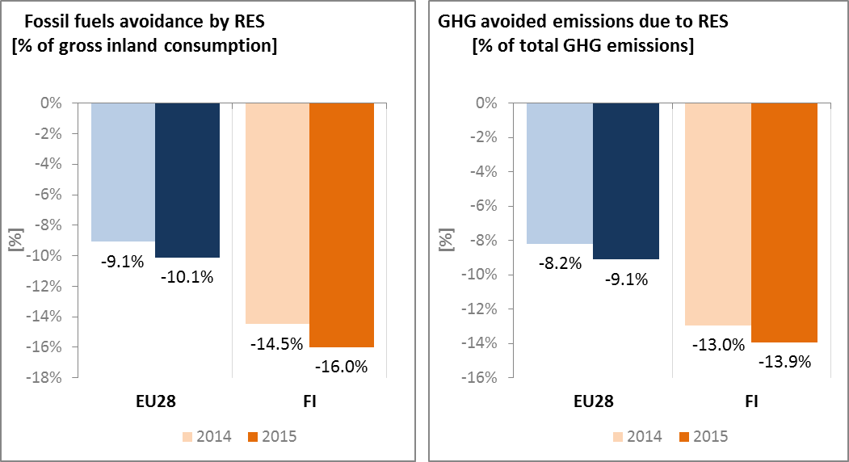

*(source: EEA)*

* 1. **Contribution of the Energy Union to better air quality**

Air quality in Finland continues to give cause for concern. For the year 2013, the European Environment Agency estimated that about 1,730 premature deaths were attributable to fine particulate matter (PM2.5) concentrations[7].

Furthermore, for NO2, Finland reported exceedances of the binding EU air quality standard[8]. For the year 2015, Finland reported exceedances of the limit value for NO2 in 1 out of the 14 air quality zones in Finland[9].

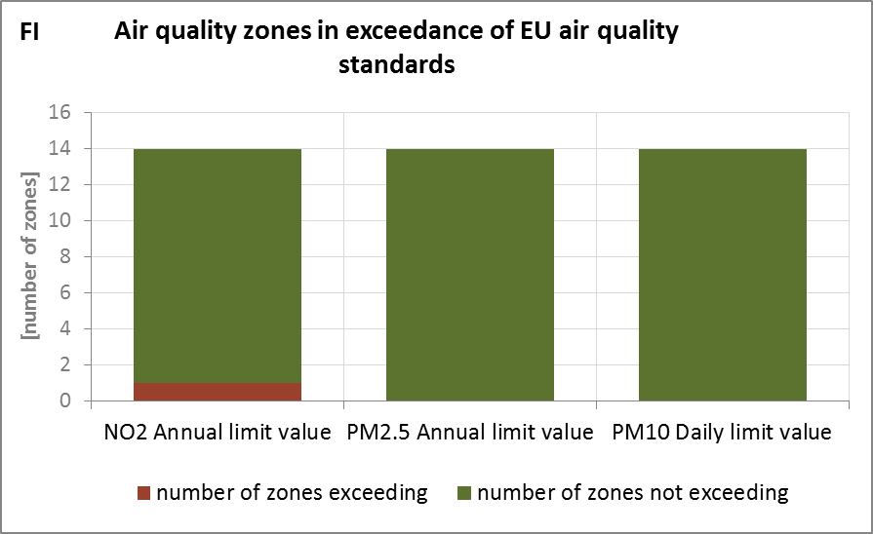

*(source: EEA)*

The health-related external costs from air pollution in Finland have been estimated to be more than EUR 2 billion/year (income adjusted, 2010), which includes the intrinsic value of living a healthy life without premature death as well as the direct costs to the economy such as healthcare costs and lost working days due to sickness caused by air pollution[10].

The Energy Union can substantially contribute to addressing these air quality problems through measures reducing emissions of both GHG and air pollutants such as PM and nitrogen oxides (NOx) from major contributing sectors such as (road) transport, energy production, industry and residential heating (e.g. stoves and boilers)[11].

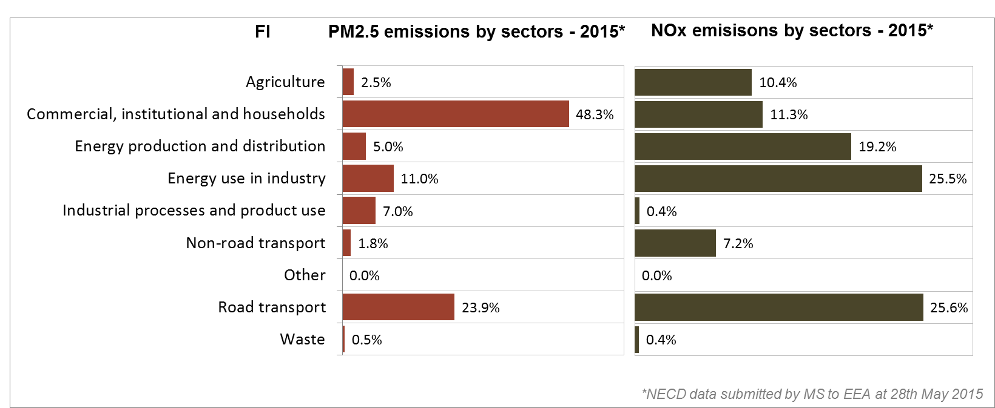

*(Source: EEA. This table reflects only sources of primary PM2,5 emissions.)*

1. **Research, innovation and competitiveness**
   1. **Research and innovation policy**

Research on clean energy technologies is considered a priority in Finland. Finnish industrial policy has embraced low-carbon innovation strategies, including the development of bio-energy from by-products. This has notably been supported by the use of EFSI funds to finance the construction of a new large-scale bio-product mill in Finland (Äänekoski). Other examples include public-private cooperation to promote innovative electric bus making in Finland, or the St1 Deep Heat project which will involve drilling seven-kilometre wells for pilot geothermal heat production, and which received EUR 10 million governmental grants.

In a European context, Finland is an active contributor to the ongoing work of the Strategic Energy Technologies (SET) Plan. More specifically, it currently leads the temporary working group for the implementation of the integrated SET Plan actions on energy efficiency in industry, and co-leads the one on renewable fuels and bioenergy. It also participates in another three temporary working groups dedicated to nuclear safety, smart solutions for energy consumers and smart cities and communities.

Finland is also involved in the Horizon 2020 programme, so far receiving 2. 8 % of the EU contribution devoted to the 'secure, clean and efficient energy' part of the programme. As of September 2017, 89 participations from Finnish organisations have been awarded EUR 50 million in Horizon 2020 energy projects. This includes a grant of EUR 9.5 million to the Finnish company Wello Oy for its participation in project CEFOW to produce clean energy from ocean waves. It also includes a grant of EUR 5.2 million to the Finnish participants in project my SMARTLife - Smart transition of EU cities towards a new concept of smart life and economy. Finland is also amongst the countries with a highest share of coordinators amongst participants and a highest number of project coordinators per capita.

Globally, Finland joined the Mission Innovation[12] initiative as a fully-fledged member in November 2016, during the Conference of Parties in Marrakesh (COP22). As a result, it has committed to double funding from a base-line level of EUR 54.9 million per year to EUR 109.8 million in 2020. Funding will be from TEKES (Finnish Funding Agency for Innovation) for clean energy research and development and from the Ministry of Employment and Economy for demonstration projects of clean energy innovations. In addition, the Finnish government has earmarked EUR 100 million for investments in demonstration projects for new clean energy technologies during 2016-2018. This subsidy scheme will be included in the doubling plan for Mission Innovation, and it will increase funding for clean energy innovations by EUR 20 million in 2016 and EUR 40 million in both 2017 and 2018.

* 1. **Investments and patents in the Energy Union R&I priorities**

In 2015, public (national) investments in the Energy Union R&I priorities reached EUR 239 million, having increased by 10 % compared to 2014. The highest share of investments (36 %) was attracted by the Efficient Systems priority of the Energy Union, followed by Sustainable Transport (28 %) and the Smart System priority (23 %). In the period 2007-2015, the maximum annual public investment was EUR 269 million, reported in 2010. In 2014, the most recent year for which data from most Member States are available, public investment per GDP in Finland was the highest among the EU Member States and almost four times the EU average.

Private investment in the Energy Union R&I priorities in 2013 was estimated at EUR 402 million (3 % of the private R&I investment in Energy Union R&I priorities in the EU). The focus was on Efficient Systems, which received 32 % of these investments, followed by the Smart System priority with a share of 29 %.

In 2013, the most recent year for which complete patent [13] statistics are available, 74 companies and research organisations based in Finland filed 159 patents in low-carbon energy technologies (2 % of the EU total). The focus was on Efficient Systems (34 %), followed by the Smart System and Sustainable Transport priorities (24 % each).

In 2013, private R&I investments and patents in Energy Union R&I priorities were higher than the EU average when normalised by GDP and by population respectively. In the period 2007-2013, both private R&I investments and the number of patents in Energy Union R&I priorities increased on average by 11 % and 24 % per year, displaying higher rates of increase than the EU indicators (6 % and 15 % respectively).

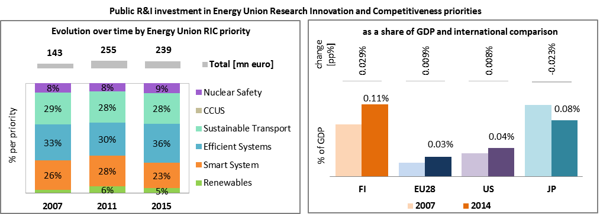

*Note: The international comparison (right) is shown for 2014 (Finland had reported EUR 218 million). Reporting at EU level for 2015 is not as complete, and very few countries have reported for 2016.* 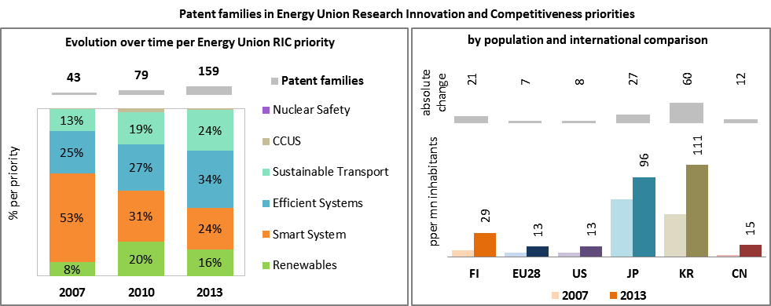

*(Data sources: Public investment as available in the International Energy Agency RD&D Statistics database[14] for codes relevant to Energy Union RIC priorities. Patent data based on the European Patent Office PATSTAT database[15]. Private investment as estimated by JRC SETIS. Detailed methodology available from the JRC[16].)*

* 1. **Competitiveness**

In 2014, the real unit energy costs (RUEC)[17] in Finland (21.8) were above those at the EU average (15.3), almost three times more than those in the US but below those in Japan and China. This can be partly explained by the specialisation of Finland in energy intensive industries.

The electricity prices paid by industrial customers in Finland are below the EU average and in line with OECD countries. Conversely, gas prices for industrial consumers are well above the EU and OECD averages. However, the impact of such high prices is mitigated by the relative low share of natural gas into final energy consumption in industry.

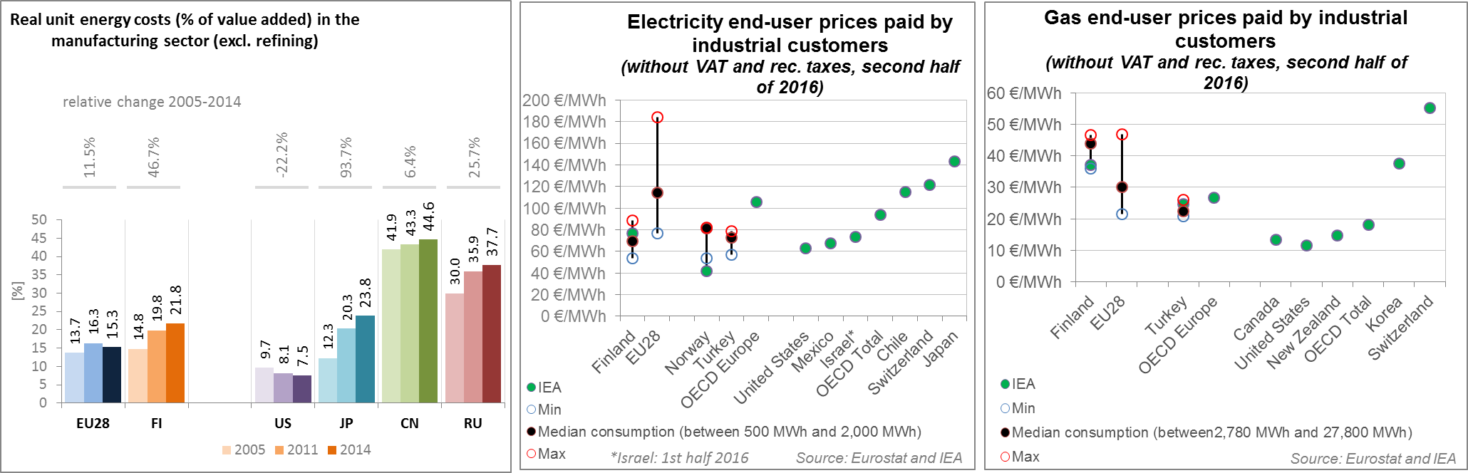

*(source: ECFIN) (source: Eurostat and IEA)*

Regarding the competitiveness in wind and solar energy, Finland is performing quite well in the wind sector due to a comparative advantage in key components of wind turbines such as blades, gearboxes and generators. However, this is not the case for solar PV, as Finland exports less solar PV panel components, when compared to its total exports, than other countries. Although not necessarily directly linked (as a country could specialise in exporting a technology that is not deployed on its territory), this is in line with the fact that solar PV is not a major energy option for Finland. The relative trade balance[18] confirms that Finland is a net exporter of wind components, above the EU average.

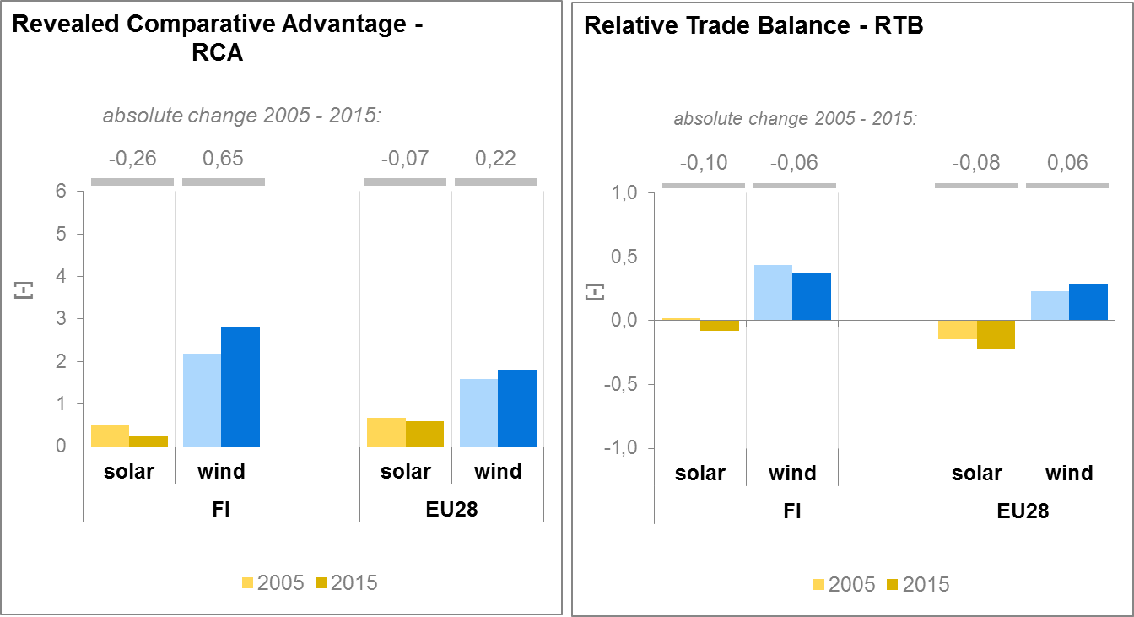

*(source: UN comtrade)*

1. **Regional and local cooperation**

Finland is part of the Baltic Energy Market Interconnection Plan (BEMIP), the first High-Level Group launched in 2009 by the Commission and Denmark, Sweden, Poland, Finland, Estonia, Latvia, Lithuania, Germany and Norway (observing status). BEMIP’s main objectives are to develop an internal and regional energy market between the EU Member States in the Baltic Sea region and integrating it fully into the EU's energy markets thus increasing security of supplies. BEMIP projects have been part of the European Economic Recovery Plan (EERP) and the Trans-European Energy Networks Programme. BEMIP projects have also been funded through the EU's structural funds, including the European Regional Development Fund (ERDF) and the Cohesion Fund (CF). Many infrastructure projects are supported through CEF co-funding amounting to EUR 534.3 million. In the framework of the societal challenge for secure, clean and efficient energy of the Horizon 2020 programme, EUR 16.9 million are allocated to participants from the Baltics to stimulate research and innovation in this field.

Finland is also part of Nordic Cooperation together with Denmark, Iceland, Norway, Sweden, as well as the Faroe Islands, Greenland, and Åland. As part of the modernisation and reform process towards a 'New Nordic Region', it was decided to commission strategic reviews of all sectors. On 27 October 2015, the energy ministers agreed to commission a strategic review of co-operation in their sector. The objective is to ensure effective co-operation now and for the coming 5 to 10 years. The report on this review was released in June 2017.

The electricity markets of Norway, Sweden, Finland, Denmark, Estonia, Latvia and Lithuania together form the Nordic and Baltic electricity market. The common electricity market combines the wholesale markets in the Nordic and Baltic countries, creating the price signals to produce electricity where the price is lowest. The Nordic Council tasked the Nordic NRAs (NordREG) to develop a truly common Nordic electricity market. Many steps have been taken to transform the nationals market to allow 'Nordic' consumer's access to supplier from other Member States. Recent measures include the development and progressing implementation of the supplier centric market processes and of data-hubs.[19]

The Nordic Energy Technology Perspectives 2016 presents technology pathways towards a near-zero emission Nordic energy system by 2050. The analysis is presented around the Nordic Carbon-Neutral Scenario which results in 85 % reduction of emissions by 2050 (compared to 1990 levels). The analysis is performed by Nordic Energy Research in cooperation with the International Energy Agency.

The EU macro-regional strategy for the Baltic Sea Region in which Finland takes part can be used as a basis for regional cooperation on energy. European Territorial Cooperation – 'Interreg' – under EU cohesion policy also provides further opportunities for cross-border, transnational and interregional cooperation, including in the Energy Union areas.

Cities and urban areas have a key role in the energy and climate challenge. The Urban Agenda for the EU, established by the Pact of Amsterdam in May 2016, better involves cities in the design and implementation of policies, including those related to the Energy Union. It is implemented through Partnerships, in which the Commission, Member States, cities and stakeholders work together on a number of important areas, including on Energy Transition, Urban Mobility, Air Quality, Climate Adaptation and Housing. Finland is participating in the partnerships on Urban Mobility, as member, Energy Transition, with the city of Vaasa as member, and Air Quality, with the city of Helsinki as member.

By 2016, in the context of the Covenant of Mayors, the sustainable energy action plans delivered by 10 Finish municipalities had been assessed. Overall, these 10 municipalities cover about 1.6 million inhabitants representing around 29 % of the total population. Overall, these municipalities committed to reducing GHG emissions by 24.4 % by 2020 (as compared to 1990 baseline), a lower percentage reduction than at EU level. In addition, 1 city (covering 0.14 million inhabitants) has committed to conduct a vulnerability and risk assessment and develop and implement an adaptation plan. Two more cities are signatories of the Covenant of Mayors, with 2030 greenhouse gas emission reductions and adaptation objectives.

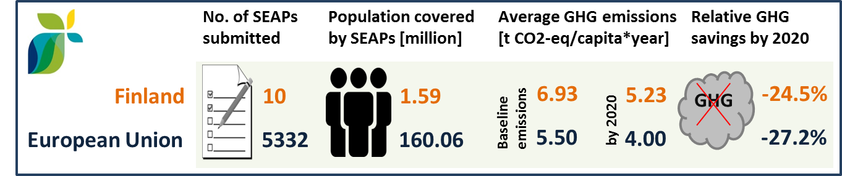

*(source: JRC 2016. Notes: SEAP=sustainable energy action plan, GHG=greenhouse gas emissions)*

1. **Cohesion policy and EU-supported clean energy investments**

EU cohesion policy makes a key contribution to delivering the Energy Union objectives on the ground, including investment possibilities to implement energy policy objectives in Finland which are complemented by national public and private co-financing, aiming at optimal leverage. It also ensures integrated territorial solutions to energy and climate challenges, supports capacity building and provides technical assistance.

Over 2014-2020, cohesion policy is investing some EUR 77 million in energy efficiency demonstrations in public infrastructure and in SMEs as well as in smart electricity distribution grids in Finland. Cohesion policy is also investing significantly in R&I and in SME competitiveness in Finland, based on the regional strategies for smart specialisation. For Finland, the strategies include a focus on energy efficiency improvements in activities, production, products/services of enterprises as well as research and innovation on energy efficiency, renewable energies and material efficiency. At this stage, at least EUR 88 million is foreseen for investments in R&I and adoption of low-carbon technologies in Finland, but this might increase further in line with the evolving content of the smart specialisation strategies. A further estimated EUR 8 million is invested in supporting the move towards an energy-efficient, decarbonised transport sector.

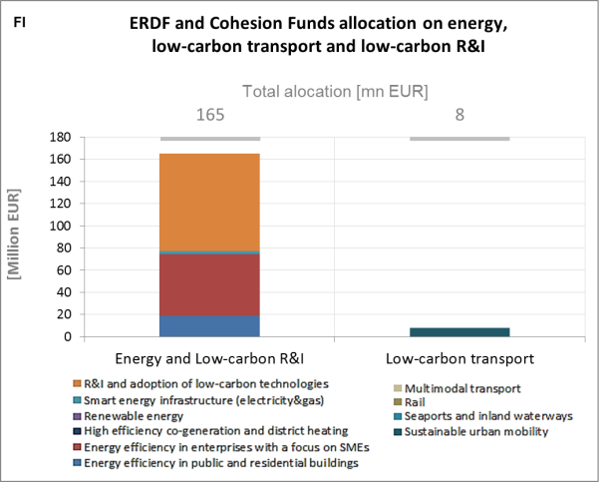

*(source: DG REGIO)*

For example, the research project on future energy storage solutions in marine installations (FESSMI), running from November 2015 to October 2017 and co-financed by the European Regional Development Fund (ERDF), investigates and develops new energy efficient solutions for marine vessels taking full advantage of hybrid technology and battery energy storages. In addition, the project also investigates support infrastructure, which allows vessel energy storage interaction with on-shore grid and renewable resources. The optimal operation of such interlinked energy system also requires a system for information management and monitoring both in harbour and on vessels, which is also studied in this project. The research methods include system modelling and simulation, performance analysis of different system alternatives in various operation conditions and small scale laboratory demonstrations. The total project cost amounts to EUR 432,000.

As another example, the central aim of the North Karelia towards oil-free and low-carbon region project, running from September 2015 to August 2018 and co-financed by the European Regional Development Fund (ERDF) is to reinforce the forerunner status of North Karelian municipalities and SMEs in introducing energy efficient, renewable energy, low-carbon and cleantech solutions. The aim is to achieve a notable reduction in fossil energy consumption and greenhouse gas emissions in target properties already during the project implementation. Demonstrations and communication have a significant role in the project. A target has been set for the reduction of greenhouse gas emissions: a 80 % drop by the year 2030.

EU's innovative financial instruments have been used in Finland to finance energy efficiency and renewable energy projects. In particular, Finland is benefitting from the European fund for Strategic Investments. First, various projects[20], have been signed to support the financing of new near-zero-energy buildings in the Helsinki metropolitan area as well as in other urban areas. Second, some projects have been signed to support infrastructure investment (such as the Infranode I investment platform to support investment in local infrastructure in the Nordic countries, or the Quaero European Infrastructure Fund). Third, a project has been approved (with Elenia Oy) that concerns a replacement programme focused on improving security of power supply for electricity networks in central Finland.

Through its support to sustainable transport systems, the Connecting Europe Facility (CEF) also contributes to the goals of the Energy Union. Following Finnish participation in CEF – Transport 2014-2015 Calls, the Finnish action portfolio comprises 26 signed grant agreements, allocating EUR 107.9 million of actual CEF Transport Funding to Finnish beneficiaries (state-of-play February 2017)[21]. The transport mode which receives the highest share of funding is maritime (61% of actual funding). Finland is active in actions aiming to integrate better maritime transport in the logistics chain, by improving the operational efficiency of ports and vessels as well as developing new technologies and promoting alternative fuels, which aim to reduce the environmental impact of this mode of transport. In the area of alternative fuels for road transport, Finland works towards identifying and studying the optimal solutions for the development of an LNG/L-CNG network and supply chain.[22]

1. The indicators used in this country factsheet largely build on indicators developed for the Commission Staff Working Document "Monitoring progress towards the Energy Union objectives – key indicators" (SWD(2017) 32 final) <https://ec.europa.eu/commission/sites/beta-political/files/swd-energy-union-key-indicators_en.pdf>
2. Gross value added and employment in NACE sectors D-Electricity, gas, steam and air conditioning supply and H-Transportation and storage
3. National accounts, Eurostat
4. Imports of natural uranium and nuclear fuels are not accounted for in these statistics. See below for more information on that point.
5. The interconnectivity level is calculated as a ratio between import interconnection and net generation capacities of the country (i.e. the 2017 value is the ratio between simultaneous import interconnection capacity [GW] and net generating capacity [GW] in the country at 11 January 2017, 19:00 pm as resulted from ENTSO-E Winter Outlook 2016/2017)
6. Avoided GHG emissions mentioned here have a theoretical character as these contributions do not necessarily represent 'net GHG savings per se' nor are they based on life-cycle assessment or full carbon accounting.
7. European Environment Agency, 2016, [Air Quality in Europe – 2016 Report](https://www.eea.europa.eu/publications/air-quality-in-europe-2016), table 10.2. The report also includes details as regards the underpinning methodology for calculating premature deaths.
8. Directive 2008/50/EC of the European Parliament and of the Council of 21 May 2008 on ambient air quality and cleaner air for Europe, OJ L 152, 11.6.2008, p.1-44
9. Compliance data as reported by the Member States as part of their official annual air quality report for the calender year 2015 (available on the European Environment Agency's (EEA) Eionet/Central Data Repository), <http://cdr.eionet.europa.eu/fi/eu/aqd>
10. See also the EU Environmental Implementation Review Country Report for Finland, SWD(2017)43 final of 3.2.2017
11. National emission data as reported by the Member States to the EEA (available on the EEA's Eionet/Central Data Repository), <http://cdr.eionet.europa.eu/fi/eu/nec_revised>
12. <http://mission-innovation.net/>
13. In the context of this document, the term 'patent' refers to patent families, rather than applications, as a measure of innovative activity. Patent families include all documents relevant to a distinct invention (e.g. applications to multiple authorities), thus preventing multiple counting. A fraction of the family is allocated to each applicant and relevant technology.
14. <http://www.iea.org/statistics/RDDonlinedataservice/>
15. <https://www.epo.org/searching-for-patents/business/patstat.html#tab1>
16. <https://setis.ec.europa.eu/related-jrc-activities/jrc-setis-reports/monitoring-ri-low-carbon-energy-technologies>
17. This indicator measures the amount of money spent on energy sources needed to obtain one unit of value added.
18. The RTB indicator for product "i" is defined as follows: ${RTB}_{i}=\frac{X_{i}-M_{i}}{X_{i}+M_{i}}$ where $X_{i}$ is the value of product's "i" exports and $M_{i}$ imports.
19. NordREG Report – 2016, Published: 2016-07-29
20. VVO Near Zero Energy Buildings; SATO Energy Efficient Buildings; Tripla Near-Zero Energy Building project with EFSI financing alone reaching over EUR 350 million
21. Note that European Economic Interest Groups and International Organisations are excluded from the analysis.
22. Source: INEA